**Remember, DSAhashtable <- DSA entry <- Contact**

**Gak langsung connect ke dsa table.**

**Dalam hash table there’s entry and in entry there’s contact.**

**Gak langsung connect/ connect langsung ke DSA Entry, be carful**

**Contact gak langung connect ke hash table.**

**Remember there’s composition (similar to aggregation), this class has that other class, if there’s a variable that hasn’t call the class (in this case heap) and just calling the function, just use arrow and not use the “<>” (block) , look at linked list. Lol**

Shell short

[6,1,13,67,2,43,12,54,19,11]

Variation of insertion sort

Gap = size / 2.

Gap = 10 / 2 = 5

Compare after 5 elements, and compare 5 – 10

[6,1,13,67,2] [43,12,54,19,11]

Now gap = gap /2 (previous gap)

Compare 6 and 43 lmao

Gap = 5/2 = 2.

Now compare 1 and 12, and compare 13 and 54, compare 67 and 19, and compare 2 and 11. Ez

And it’s now looks like this

[6,1,13,19,2] [43,12,54,67,11]

Second iteration now gap = 5, 5/2 = 2.

Now every second element now compare every second element same logic as above, [6,1] [13,19] , compare 6 and 13,

Same until gap = 1, now 2 / 2 = 1. Until it’s 1. And until it’s 1, it’s all sorted.

Counting sort lol

Not a comparssion though.

[4,2,7,1,3,8,4]

Maximum element = 8

Need to define a new array

Count size of 8 (for some reason)

And now [0,1,2,3,4,5,6,7,8]

Now , how many times it is the numbers have (sthis is like hash map)

{ 0: 0, 1:1, 2:1, 3:1, 4:2, 5:0, 6:0, 7:1, 8:1}

Defining a new count array ig?

Now for some reason, the count is added,result so, count = [0,1,2,3,5,5,5,6,7]

And now insert them to the array,

Result[i] = Count[array[i]]

Ex:

Result[i] = count[array[1]] (first element) = result[i] = count[4]

Now it’s not at the and that result[i] = 5 (coming from count by adding stuff )

And add in result,

[0,1,2,3,4,5,6,7,8] = index

[ …, … ,…., …, .., 4, … (suppose to be 7), …, …] = now the logic is like thatm put it in.

And now reduce that by “1”, now 01,2,3,4,5,5,6,

So no comparison, in comparisons, it increase by N, by this, we count the stuff and stuff, it’s O(n) right?

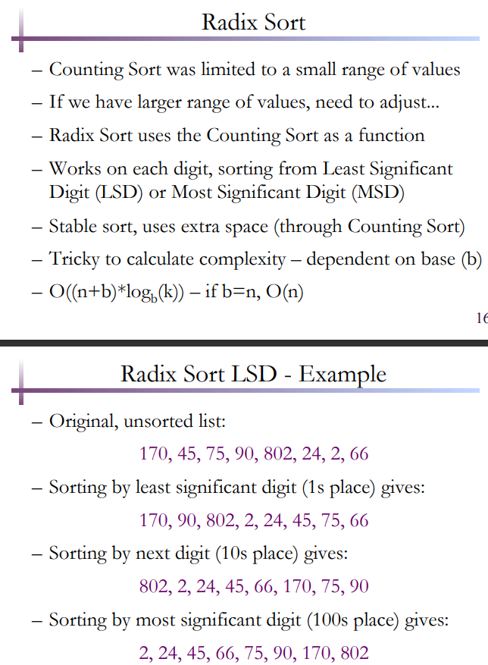

Similar to count sort by compare by 1st and 10s and 100s place, like 170, pick 0, 45 pick 5, 75 pick 5. Etc

And compare again to the 100’s like70, 45, 75, eyc.,…..

Least significant digit.